AWS LAB - 3: Introduction to Amazon EC2

Vishakha Maruti Sonmore (CSULB ID: 032188141)

College of Business, California State University, Long Beach

Course Number: I S 602 Sec08 12348 Management Information Systems

Instructor: Dr. Santos Galvez

Due date: 29-Oct-2023

**Lab 3: Introduction to Amazon EC2**

This lab provides you with a basic overview of launching, resizing, managing, and monitoring an Amazon EC2 instance. Amazon Elastic Compute Cloud (Amazon EC2) is a web service that provides resizable compute capacity in the cloud. It is designed to make web-scale cloud computing easier for developers. Amazon EC2's simple web service interface allows you to obtain and configure capacity with minimal friction. It provides you with complete control of your computing resources and lets you run on Amazon's proven computing environment. Amazon EC2 reduces the time required to obtain and boot new server instances to minutes, allowing you to quickly scale capacity, both up and down, as your computing requirements change.

**Task 1: Launch Your Amazon EC2 Instance**

Start the LAB

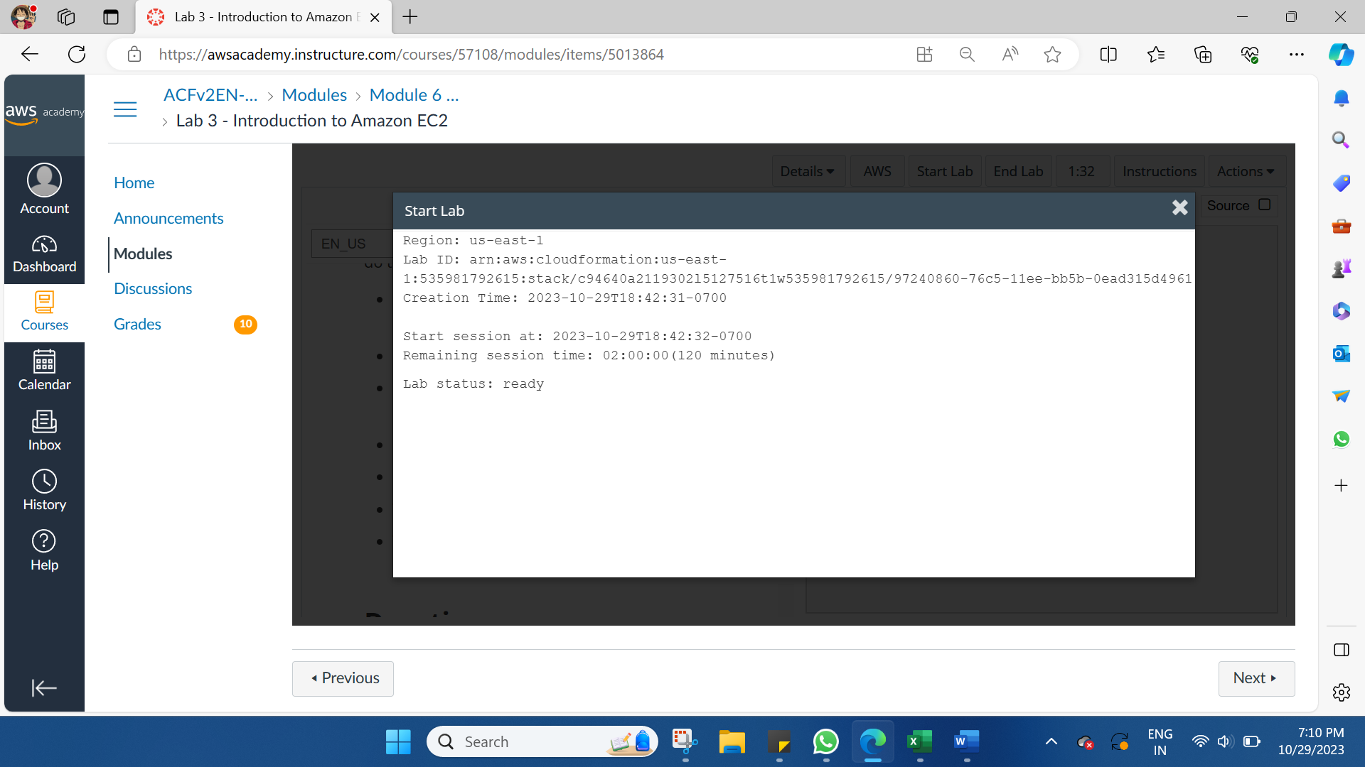

Launching an Amazon EC2 Instance and making the necessary configurations. In the AWS Management Console choose Services, choose Compute and then choose EC2.

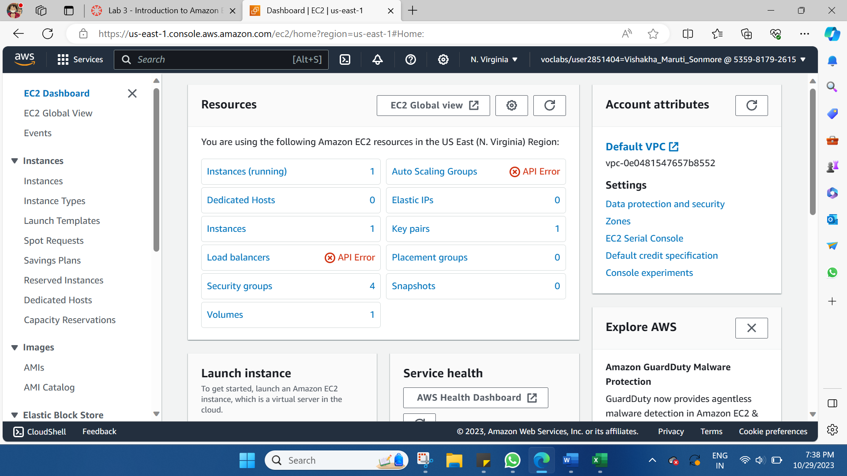

Choose the Launch instance  menu and select **Launch instance**.

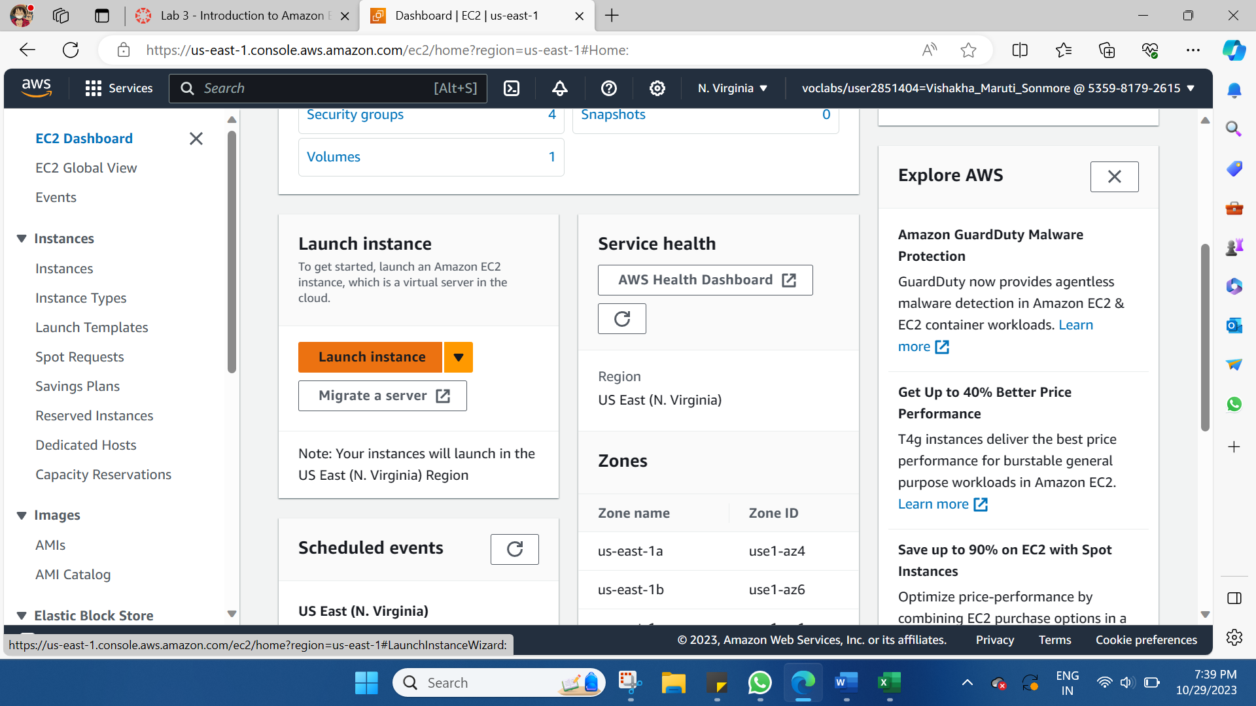

Step 1: Name and tags

Give the instance the name Web Server.

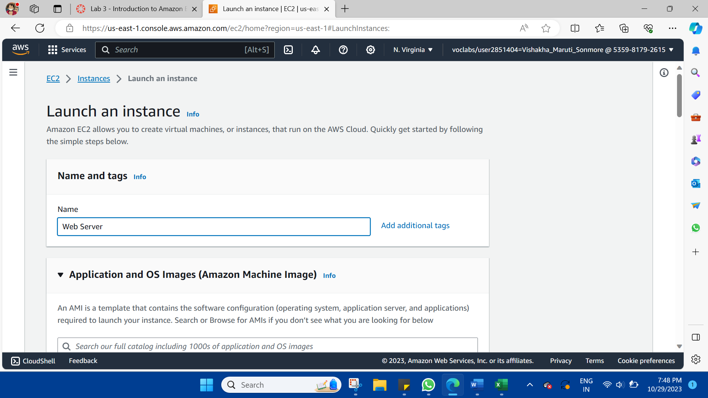

Step 2: Application and OS Images (Amazon Machine Image)

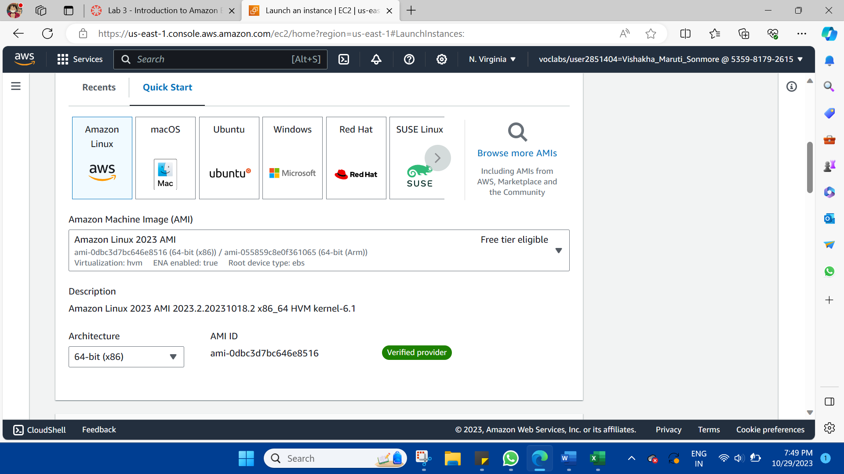

Step 3: Instance type

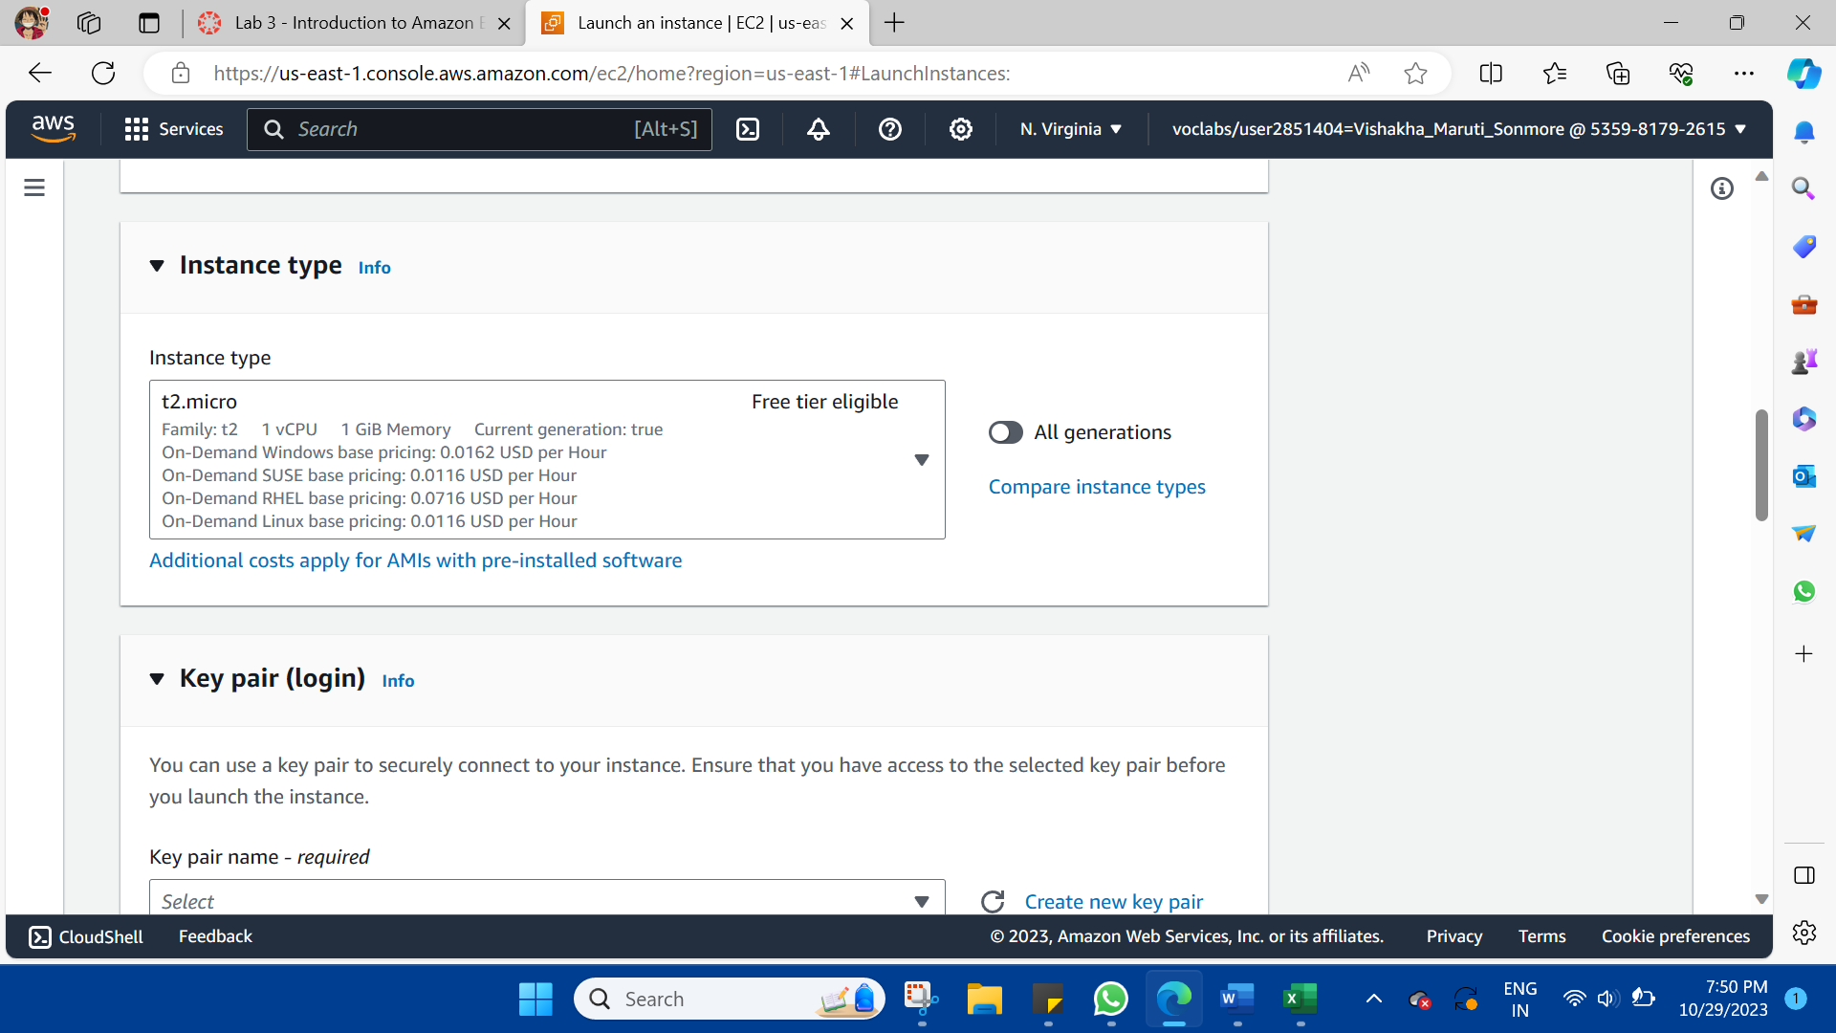

Step 4: Key pair (login)

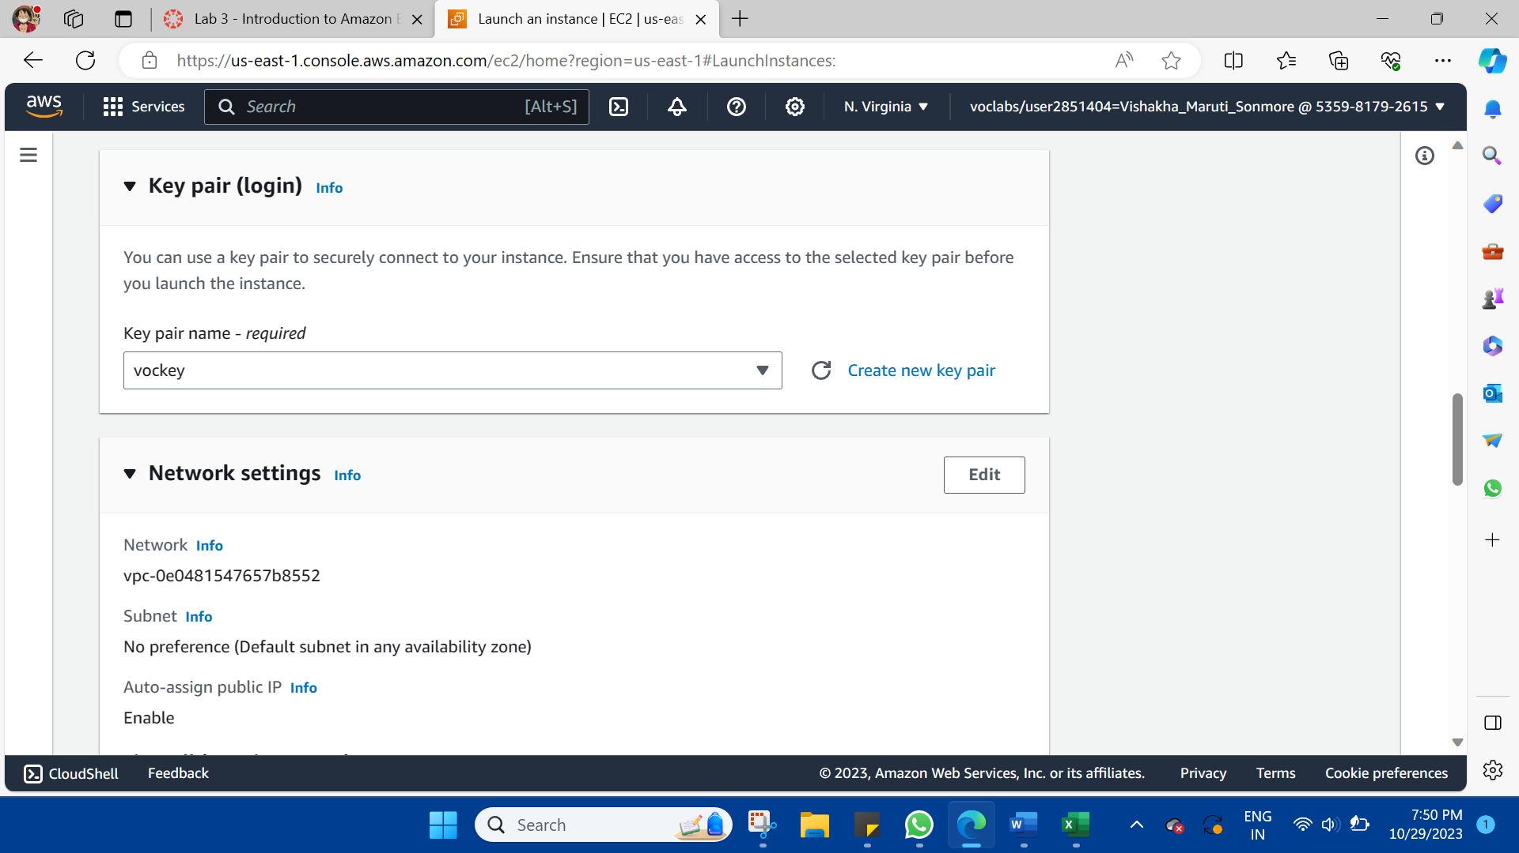

Step 5: Network settings

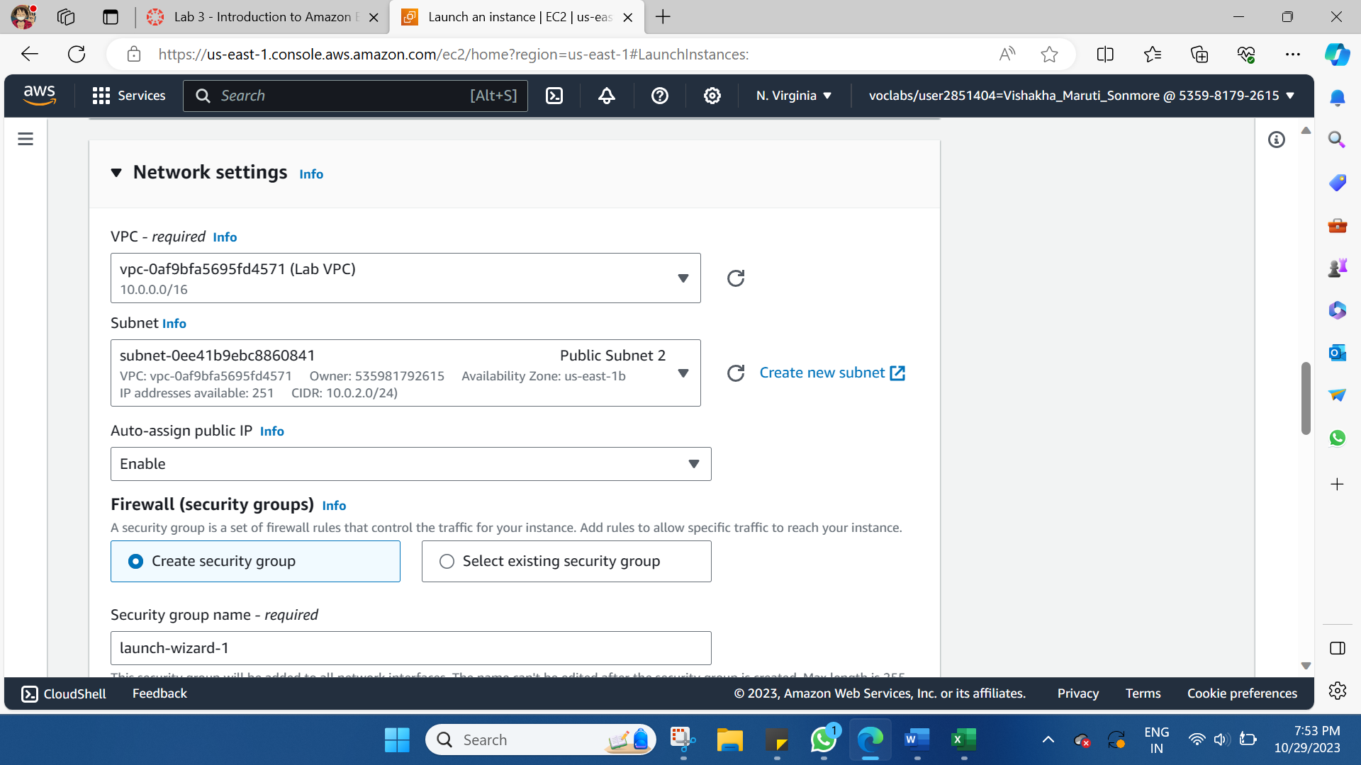

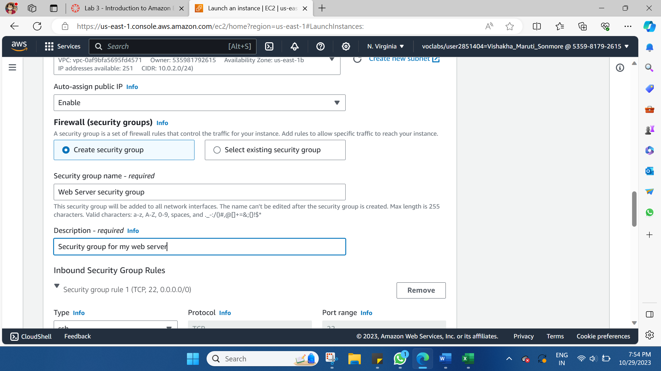

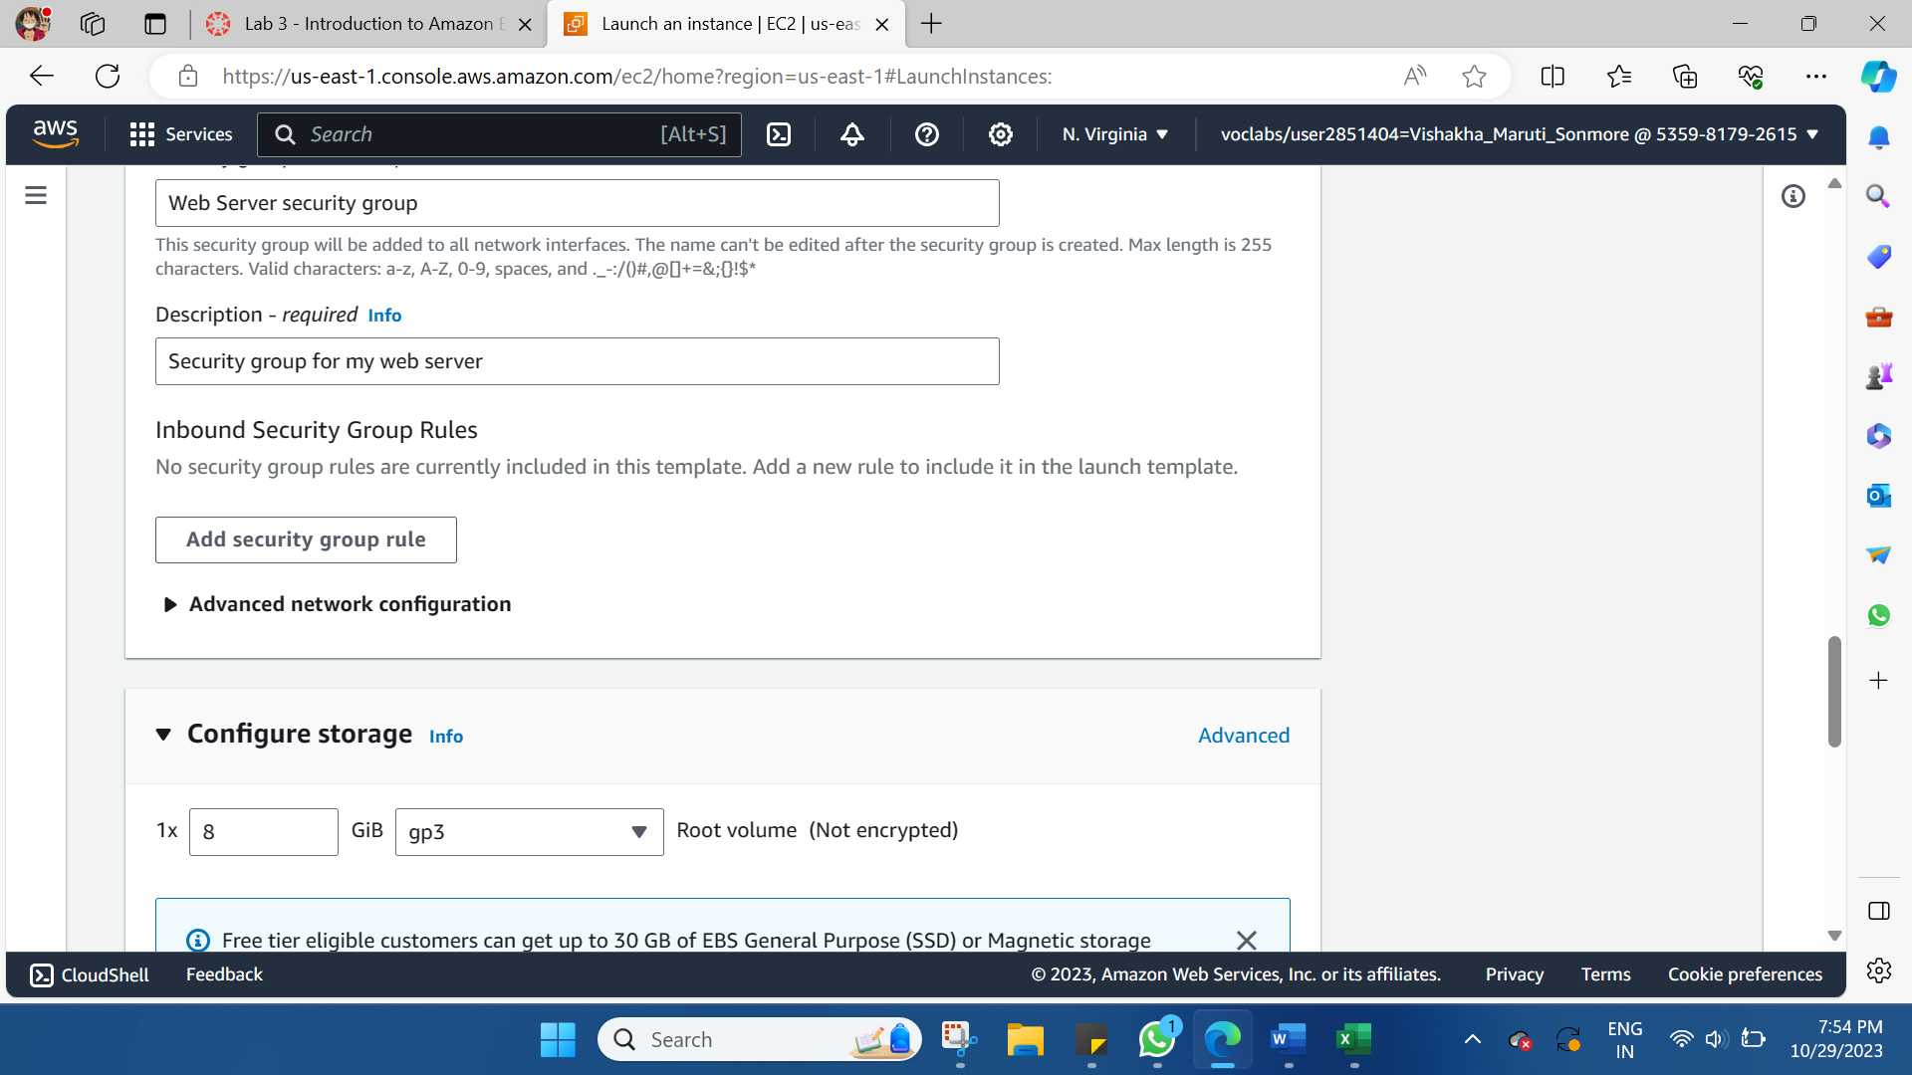

Step 6: Configure storage

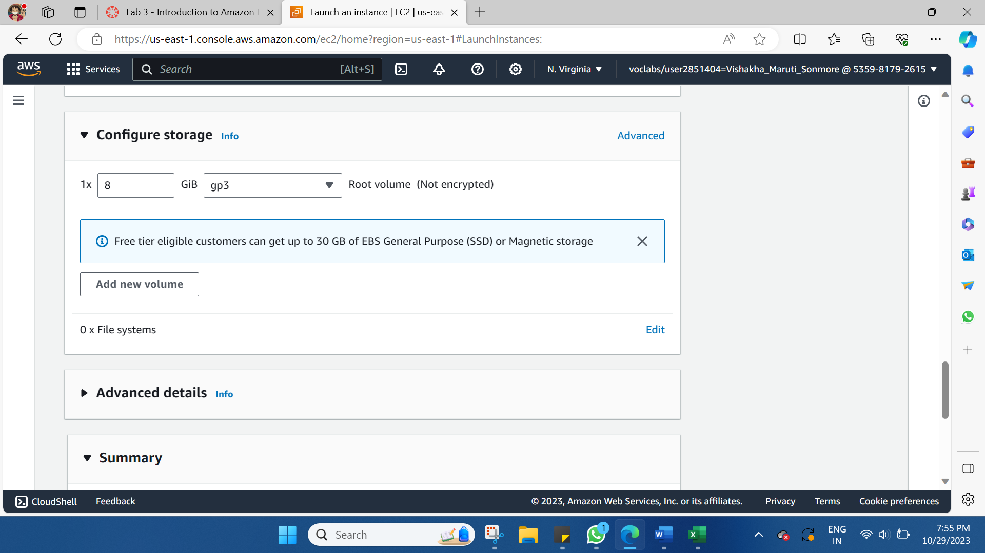

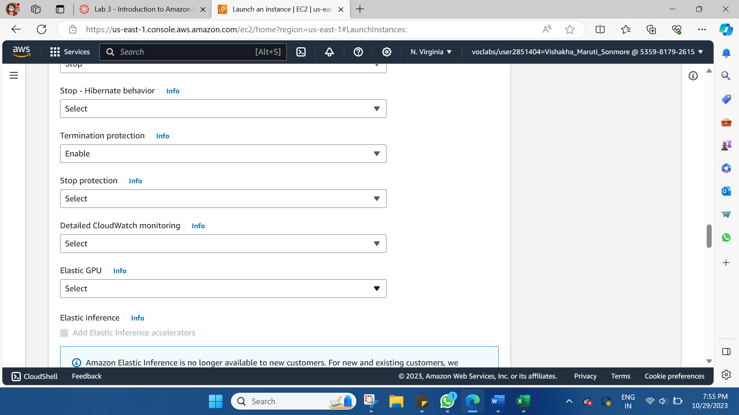

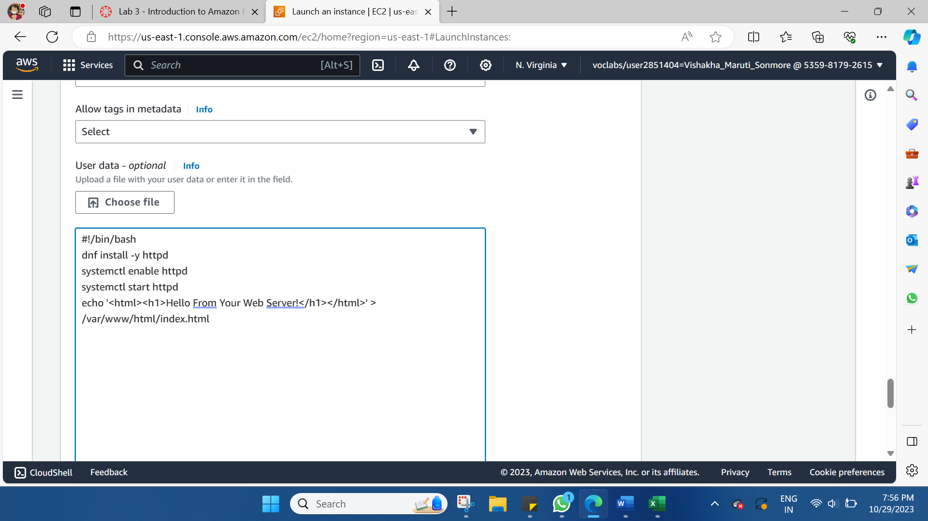

Step 8: Launch the instance

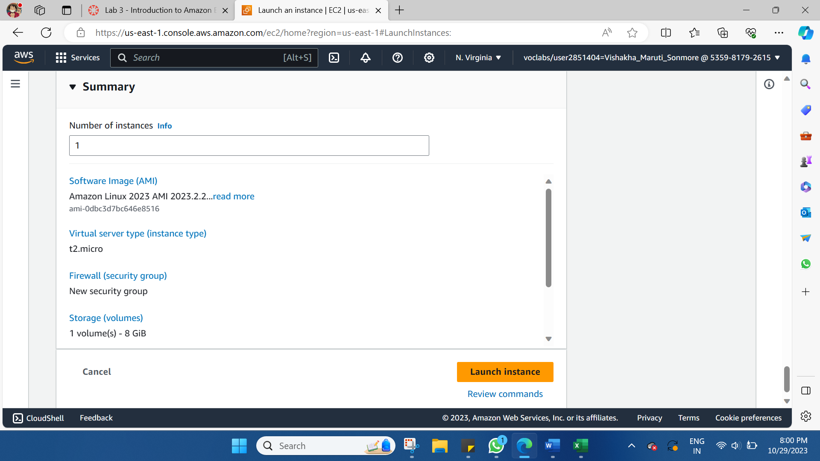

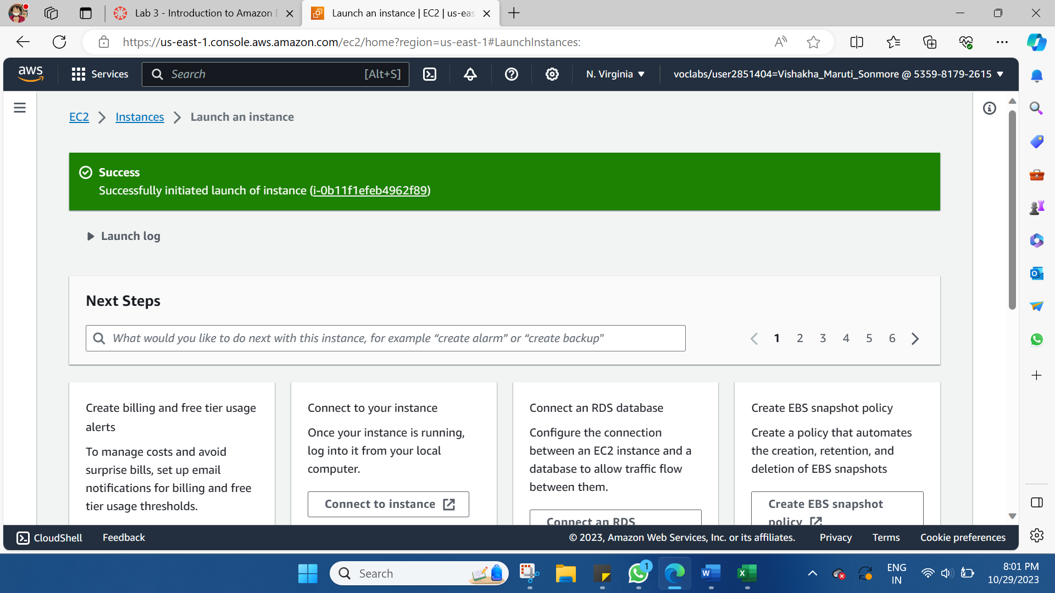

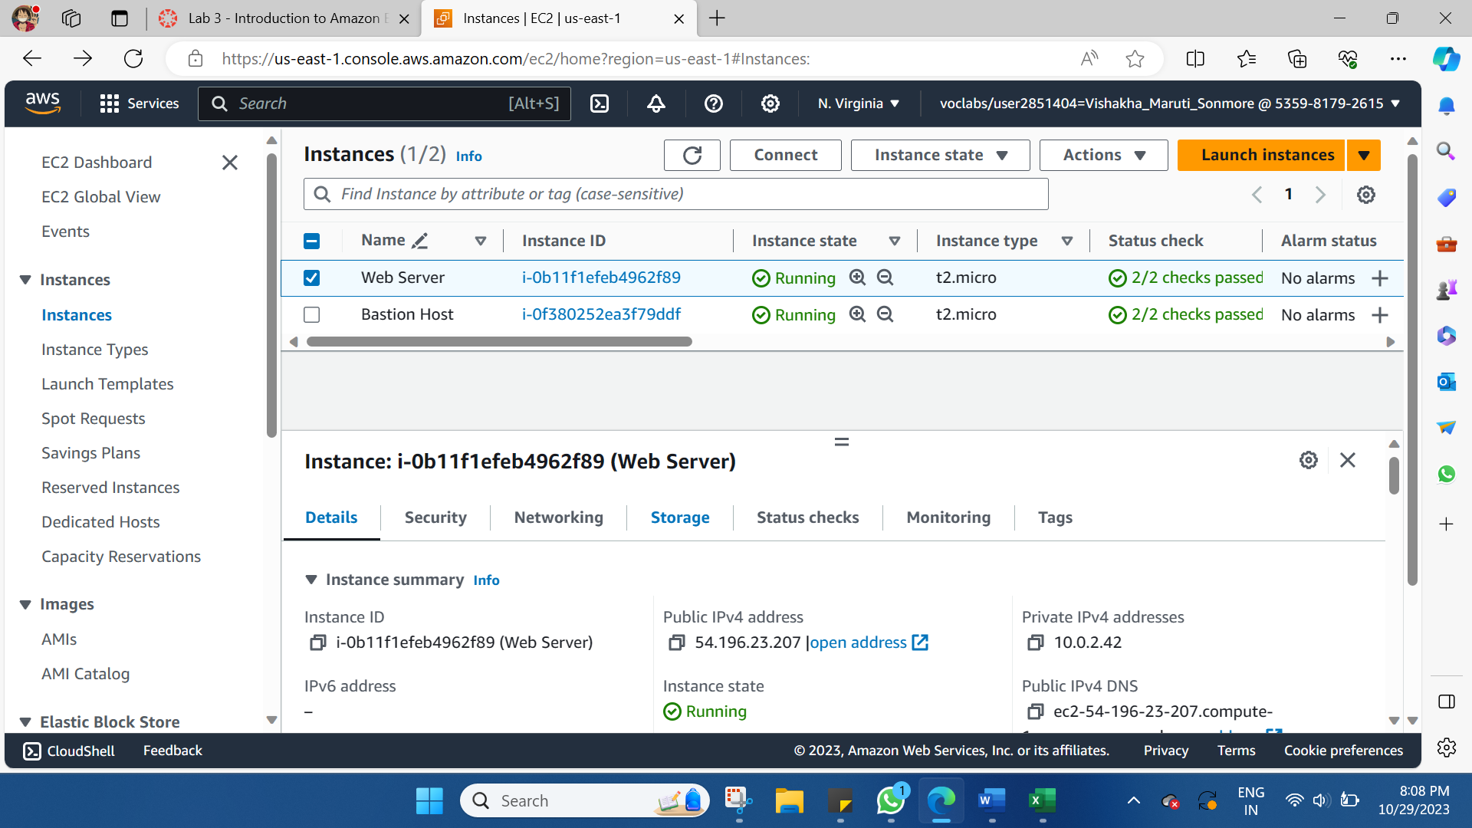

**Task 2: Monitor Your Instance**

Monitoring is an important part of maintaining the reliability, availability, and performance of your Amazon Elastic Compute Cloud (Amazon EC2) instances and your AWS solutions.

Choose the **Status checks** tab. notice that both the System reachability and Instance reachability checks have passed.

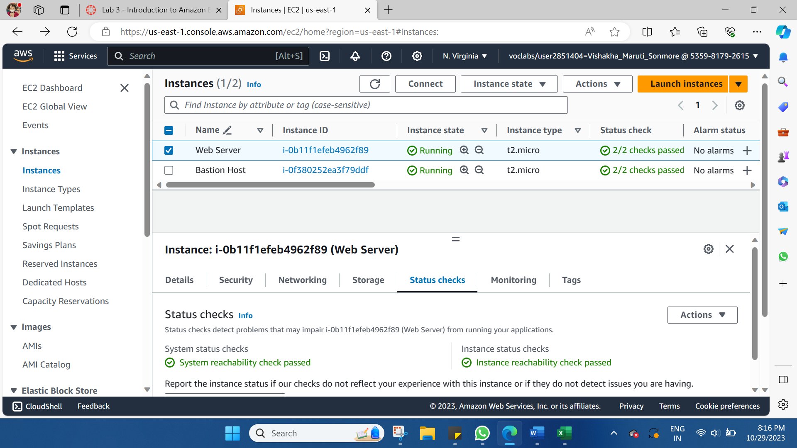

Choose the Monitoring tab.

This tab displays Amazon CloudWatch metrics for your instance. Currently, there are not many metrics to display because the instance was recently launched.

You can choose the three dots icon in any graph and select Enlarge to see an expanded view of the chosen metric. 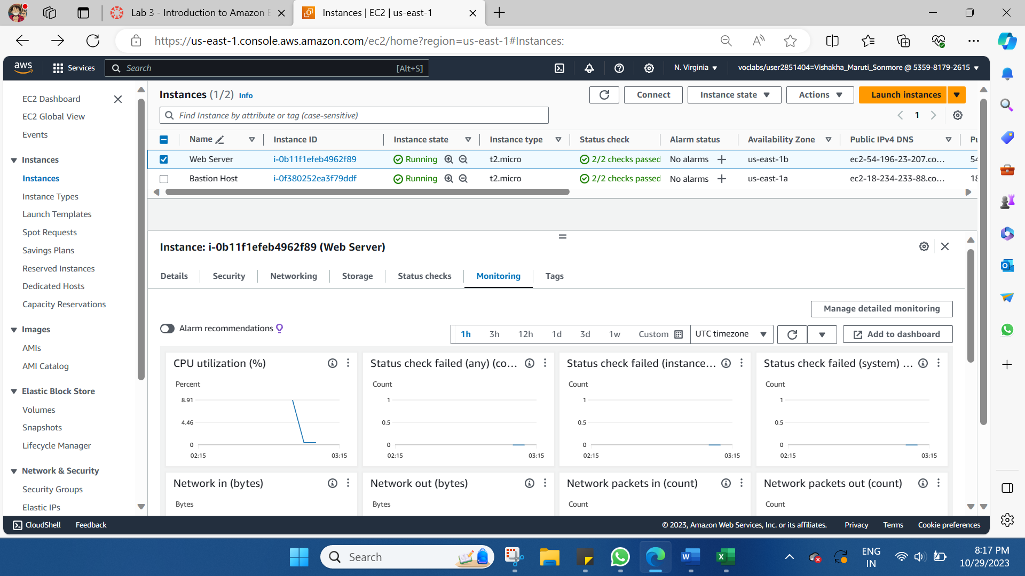

In the Actions menu towards the top of the console, select **Monitor and troubleshoot** **Get system log**.

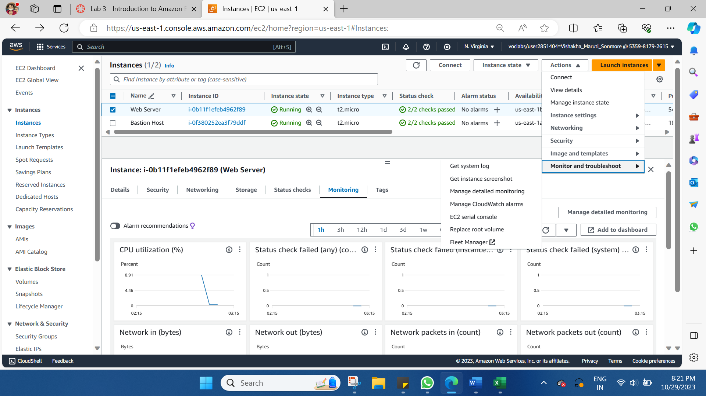

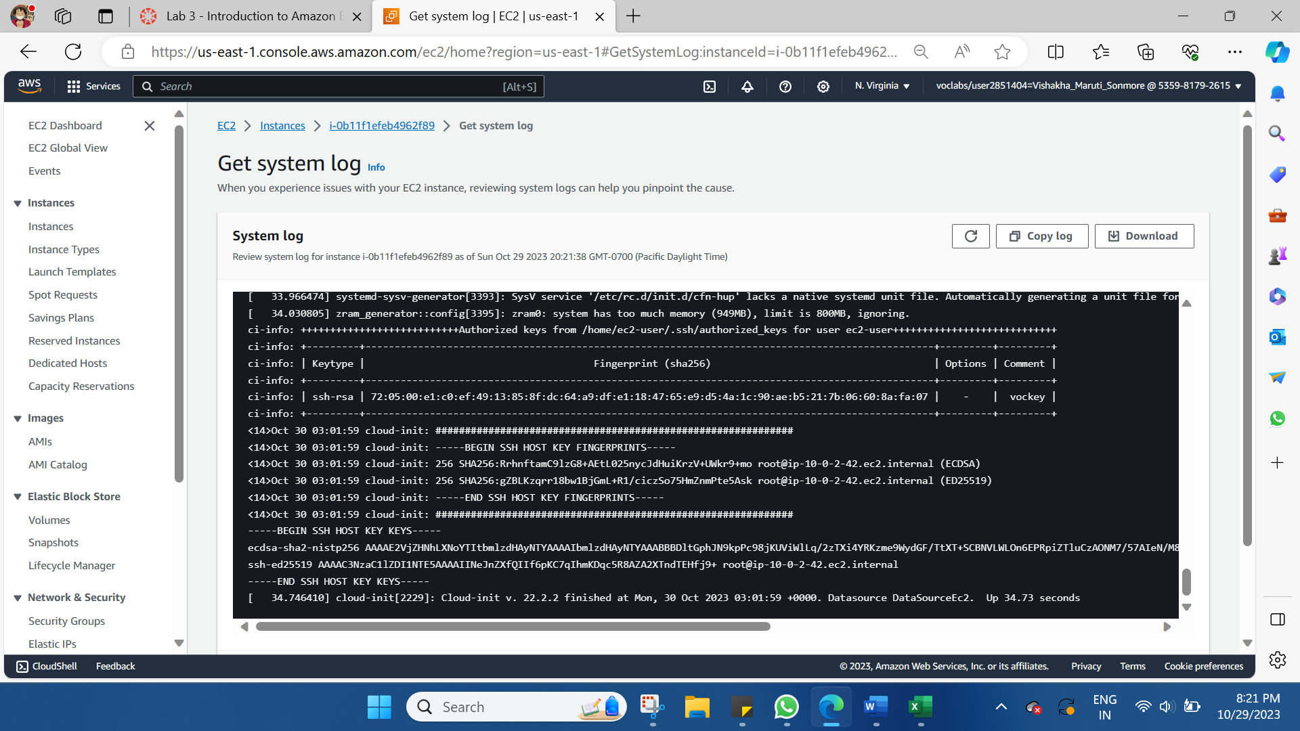

Ensure Web Server is still selected. Then, in the Actions menu, select Monitor and troubleshoot Get instance screenshot.

This shows you what your Amazon EC2 instance console would look like if a screen were attached to it.

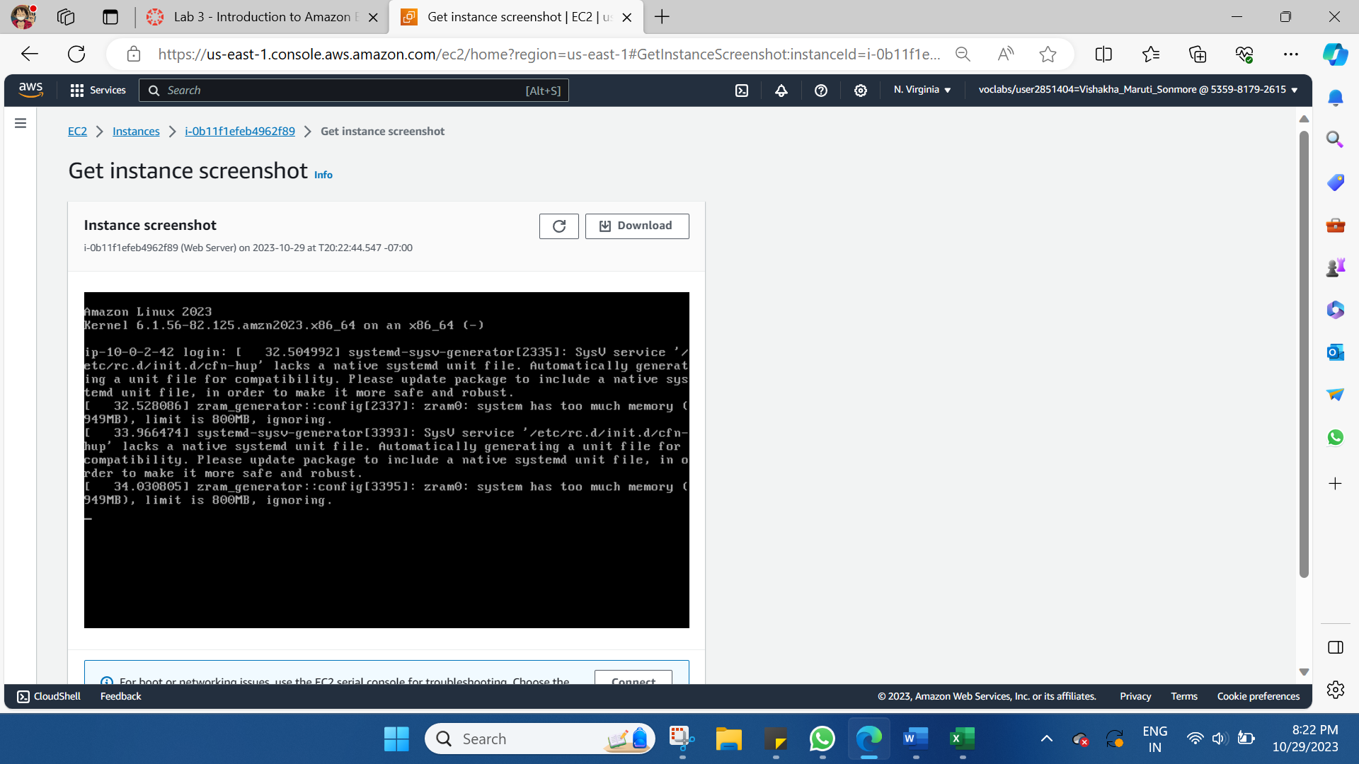

**Task 3: Update Your Security Group and Access the Web Server**

When you launched the EC2 instance, you provided a script that installed a web server and created a simple web page. In this task, you will access content from the web server.

Ensure **Web Server** is still selected. Choose the **Details** tab.

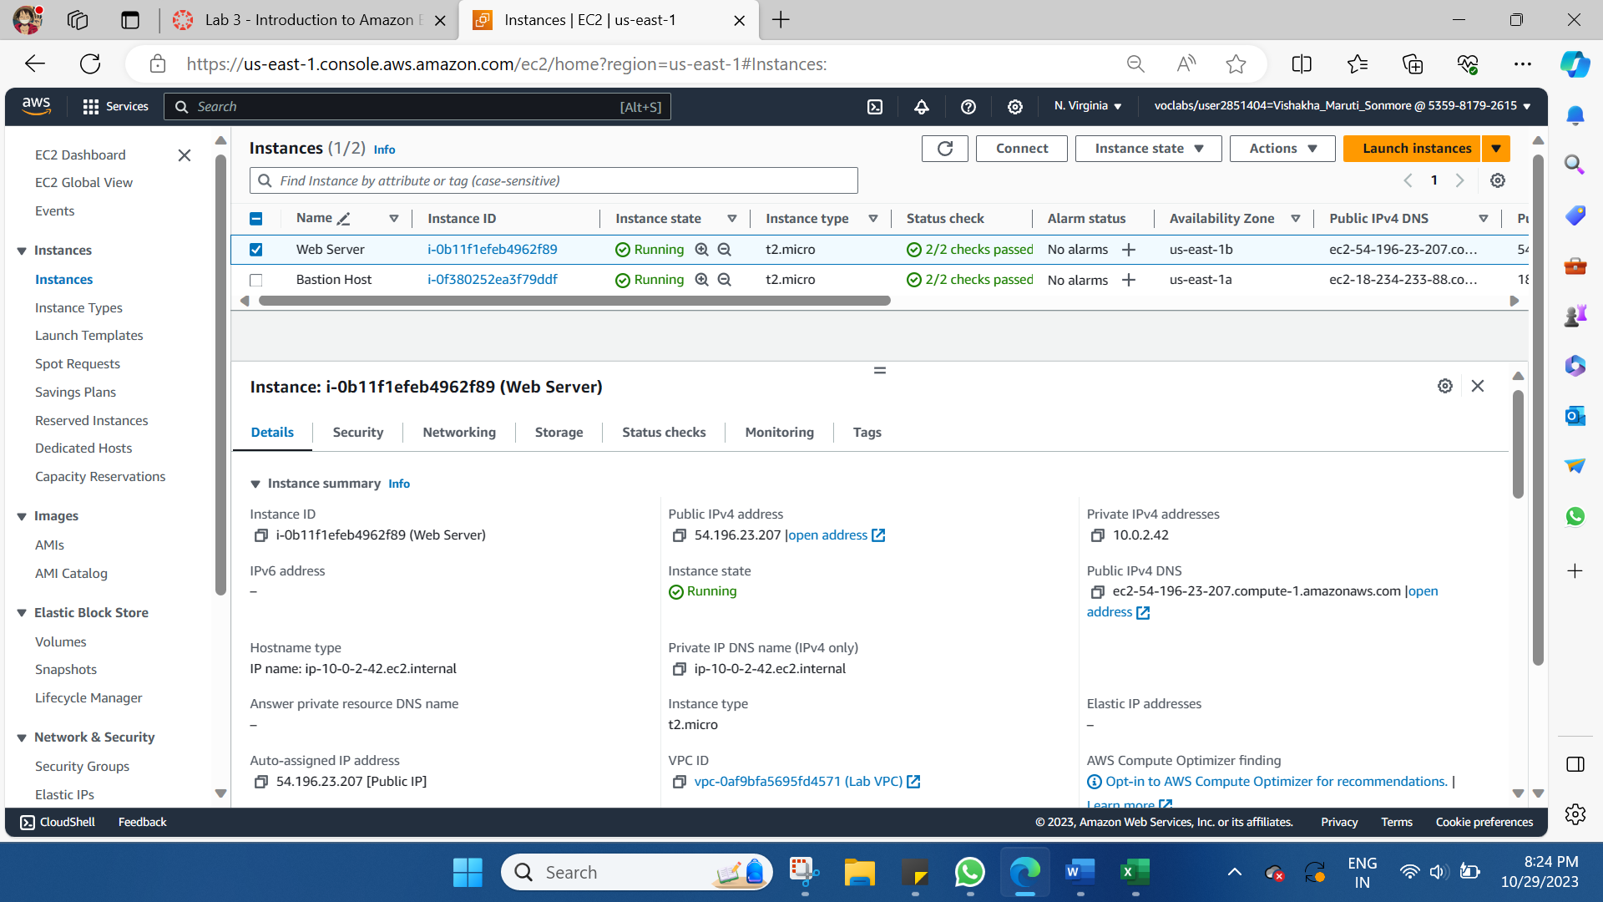

Copy the Public IPv4 address of your instance to your clipboard >>Keep the browser tab open, but return to the EC2 Console tab. >> In the left navigation pane, choose Security Groups. >> Select Web Server security group >> **Web Server security group >>** **Web Server security group**

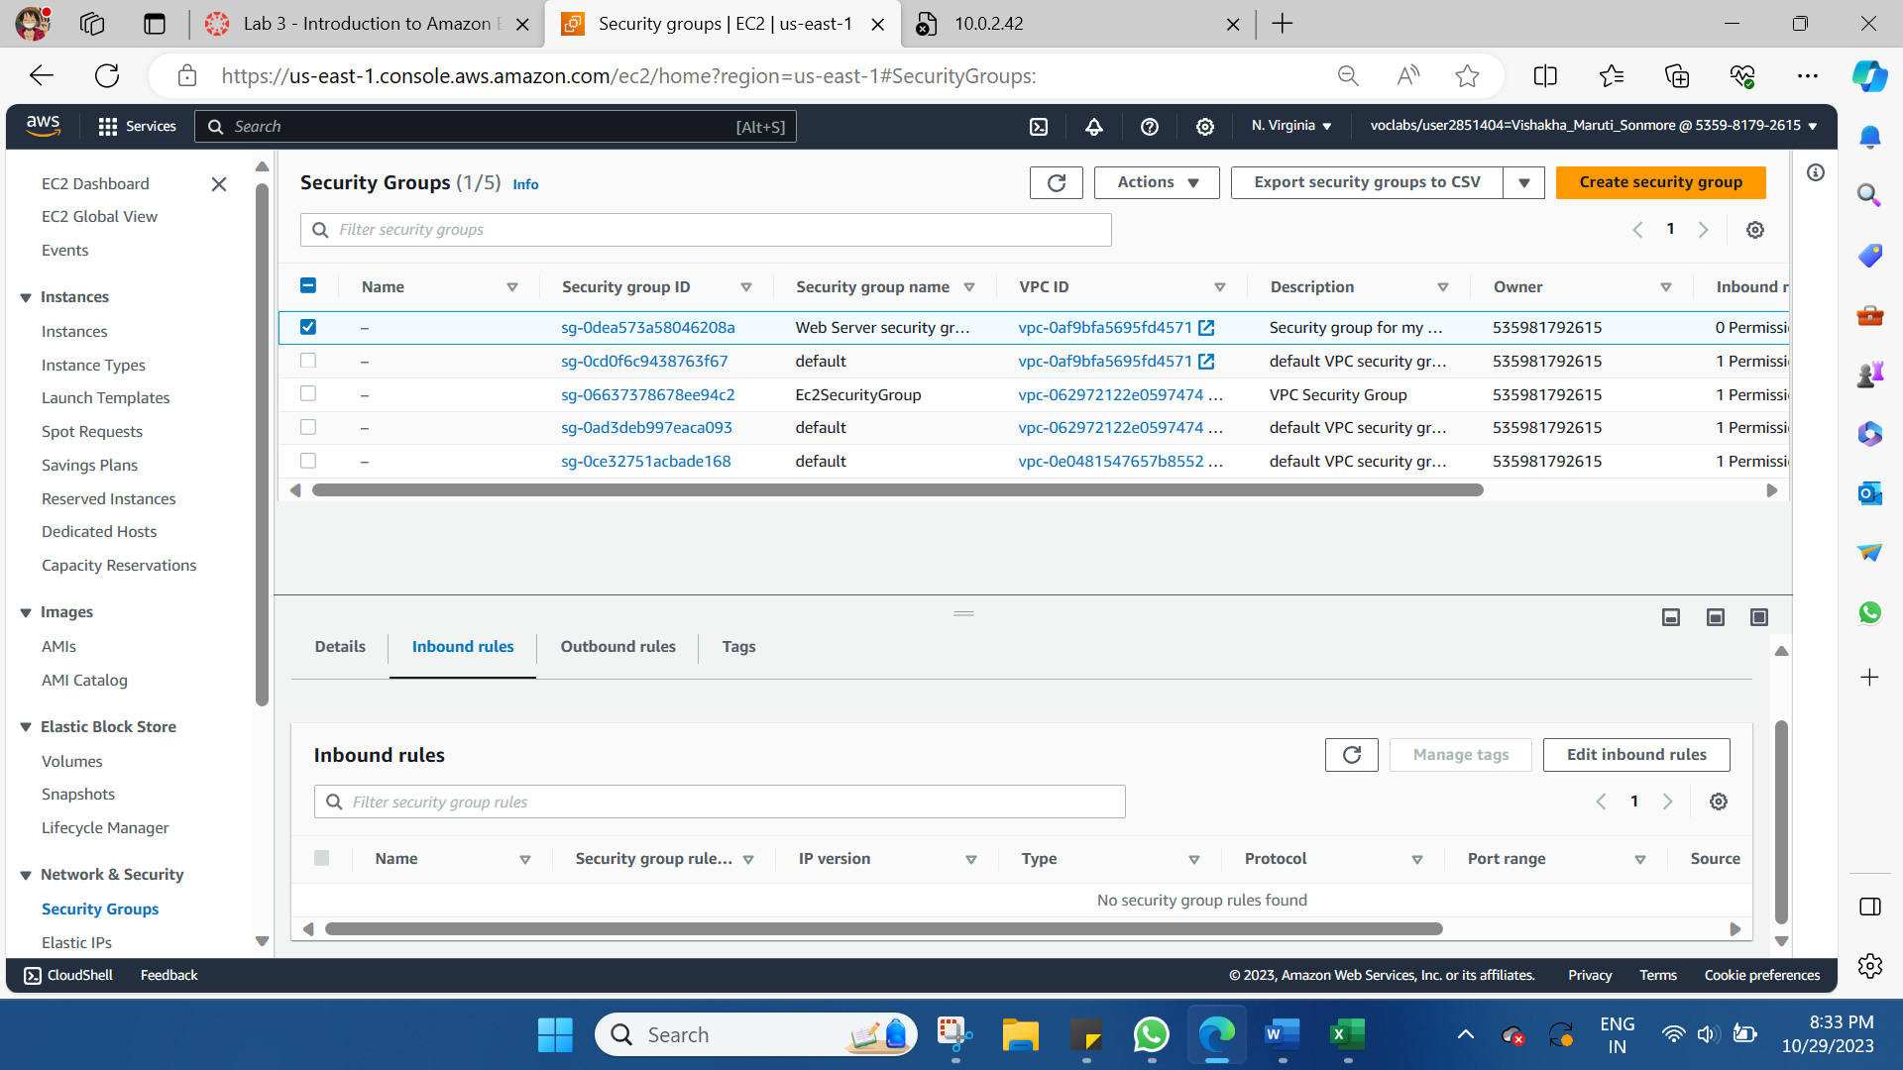

Choose Edit inbound rules, select Add rule and then configure:

* Type: HTTP
* Source: Anywhere-IPv4
* Choose Save rules

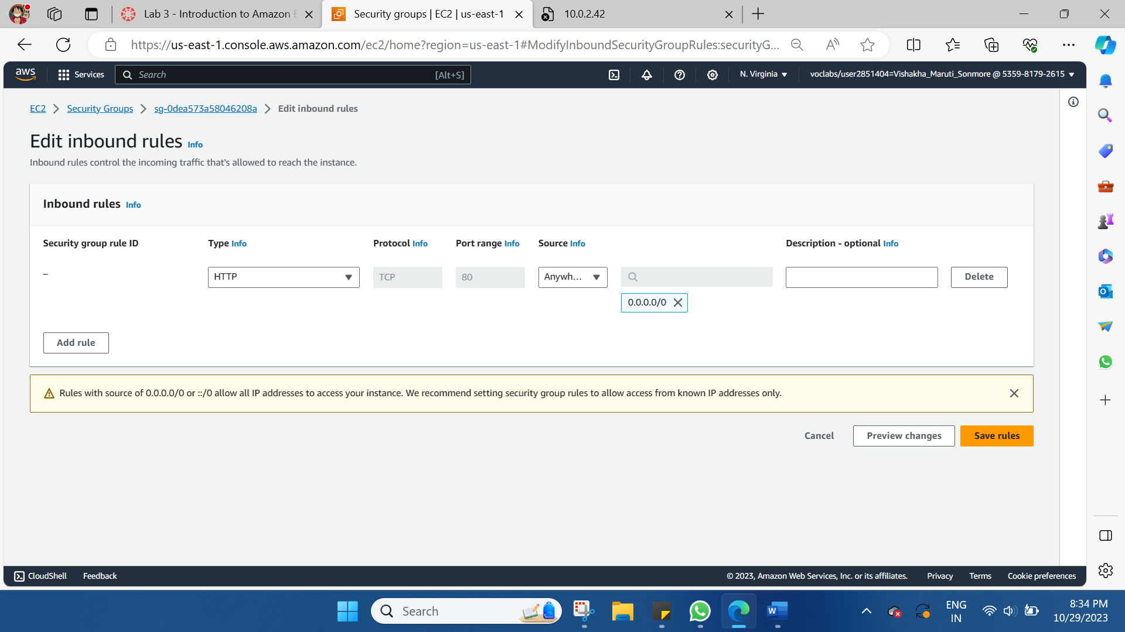

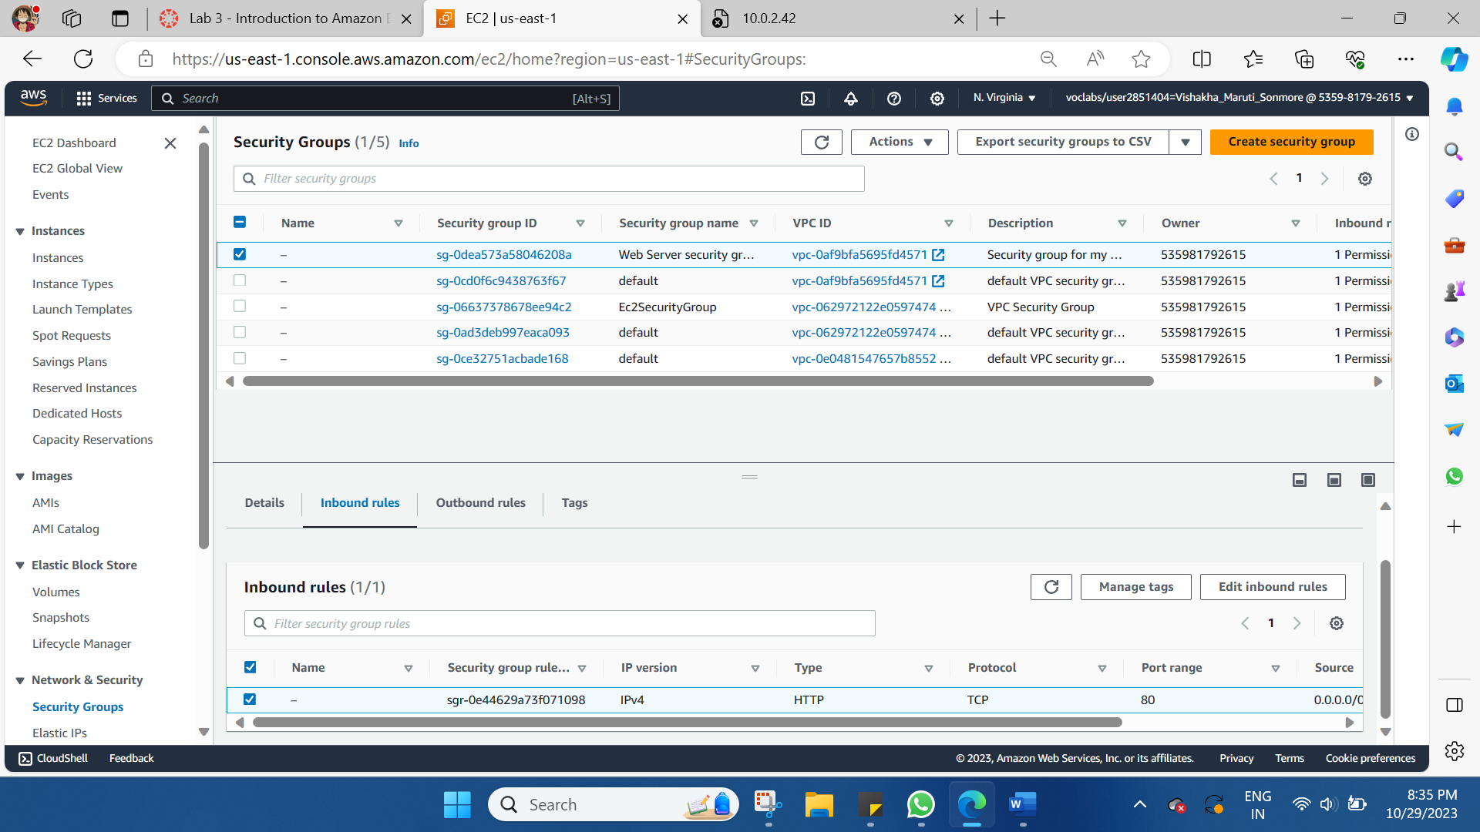

Return to the web server tab that you previously opened and refresh the page.

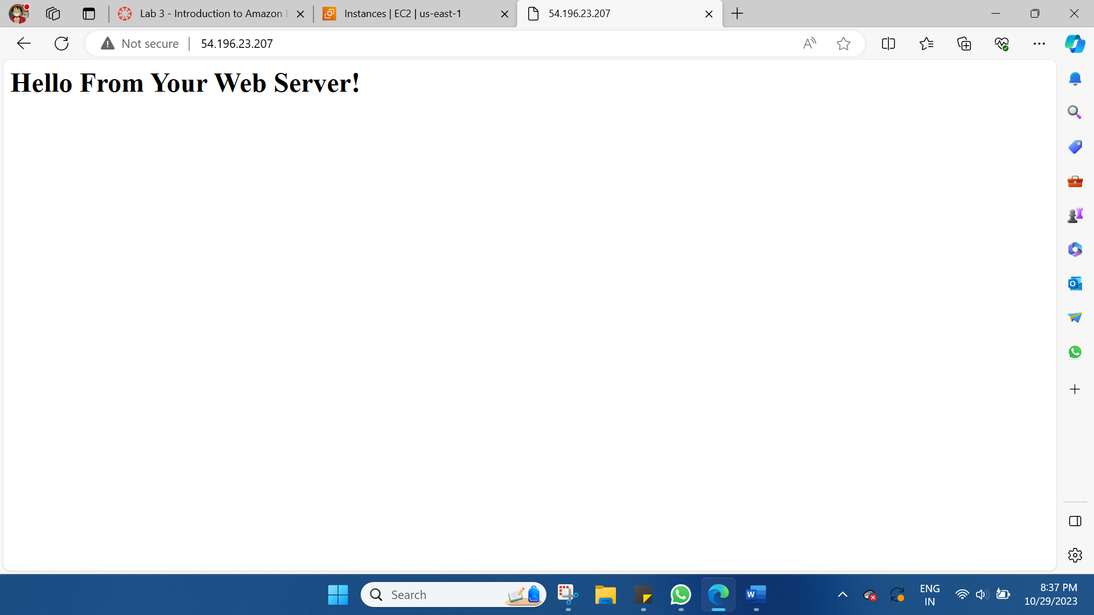

**Task 4: Resize Your Instance: Instance Type and EBS Volume**

As your needs change, you might find that your instance is over-utilized (too small) or under-utilized (too large). If so, you can change the instance type. For example, if a t2.micro instance is too small for its workload, you can change it to an m5.medium instance. Similarly, you can change the size of a disk.

Stop Your Instance

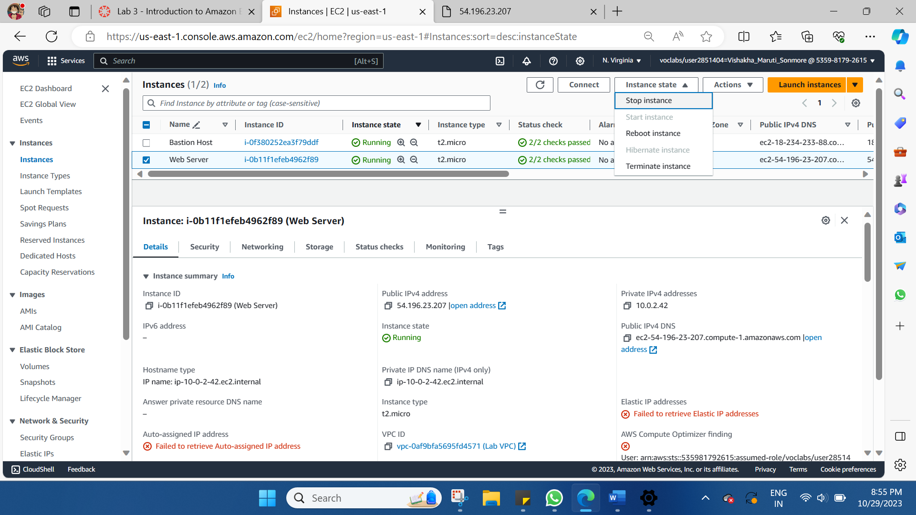

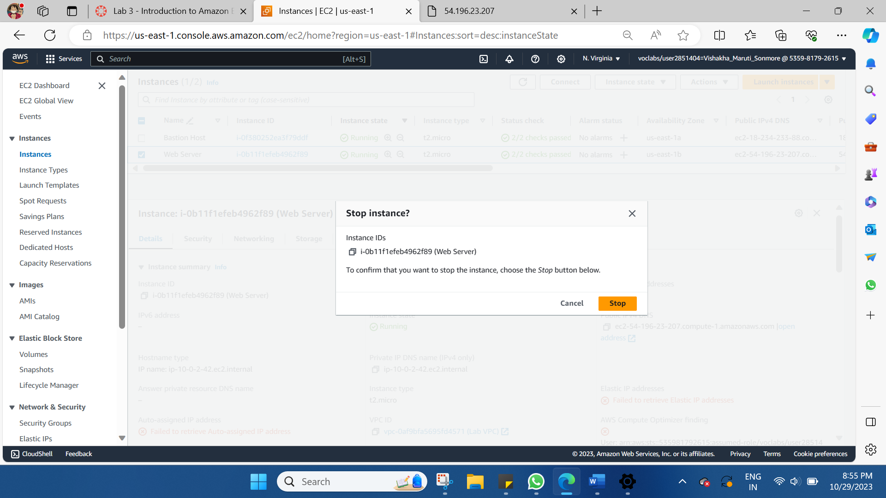

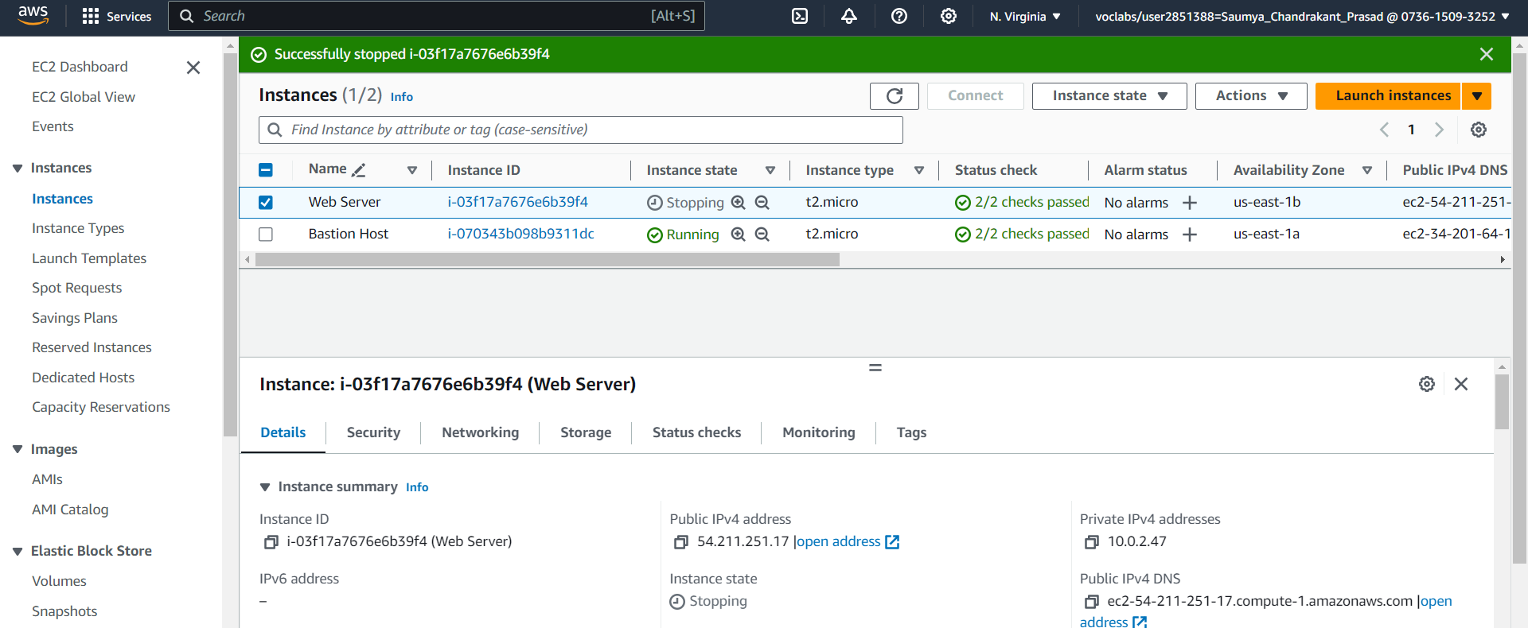

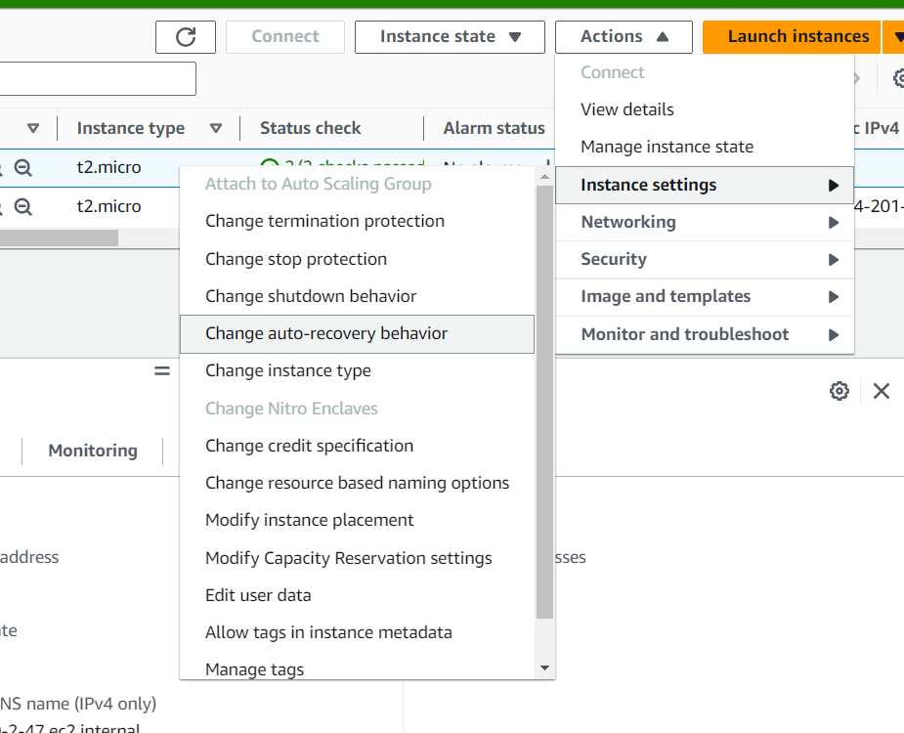

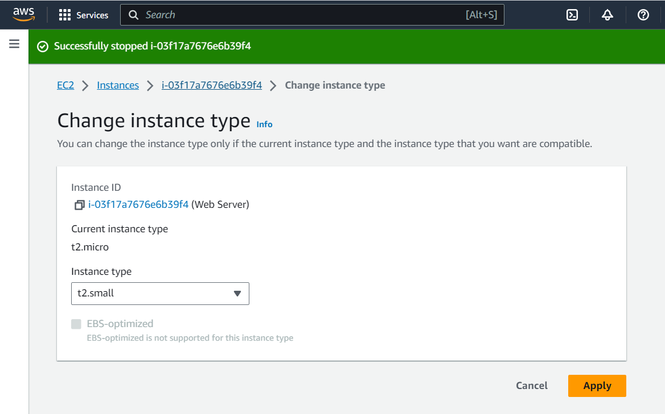

**Resizing the EBS Volume**

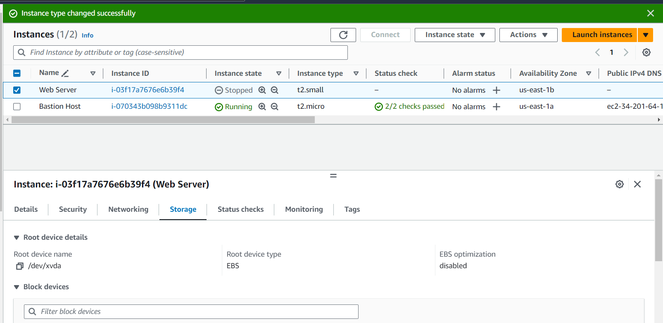

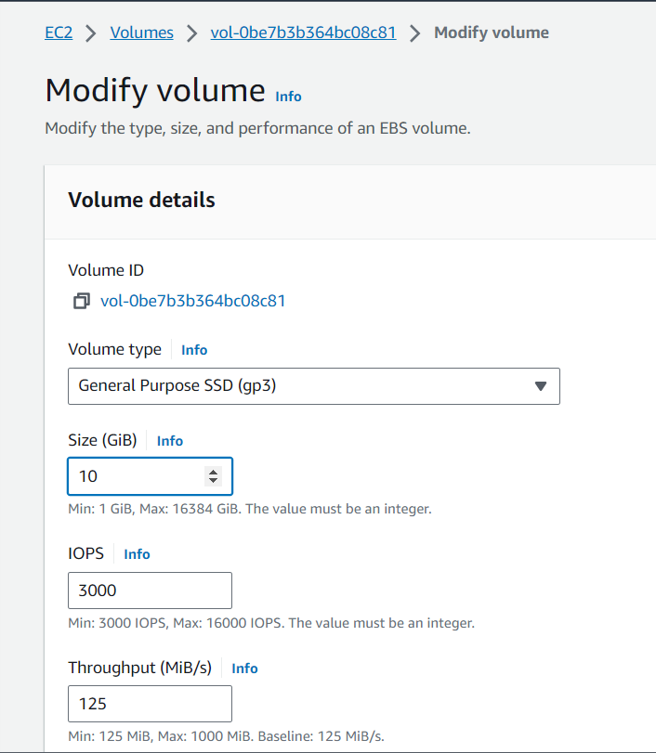

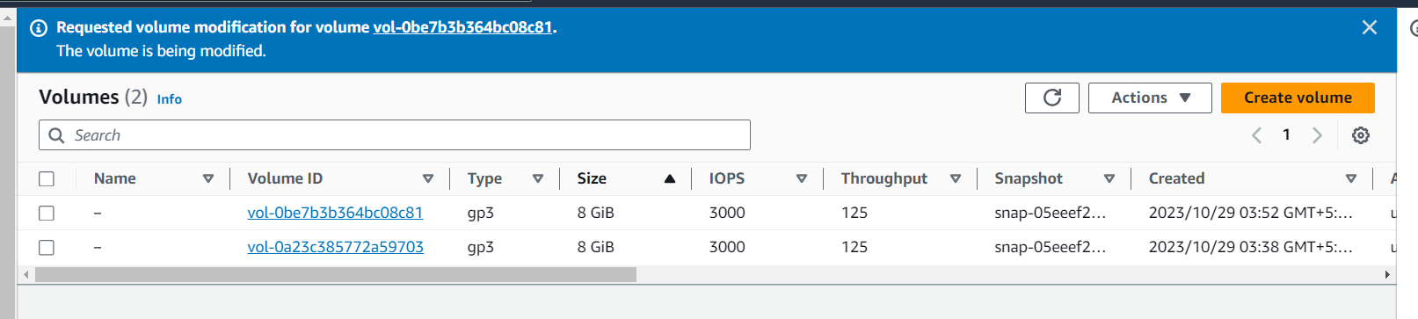

**Task 5: Explore EC2 Limits**

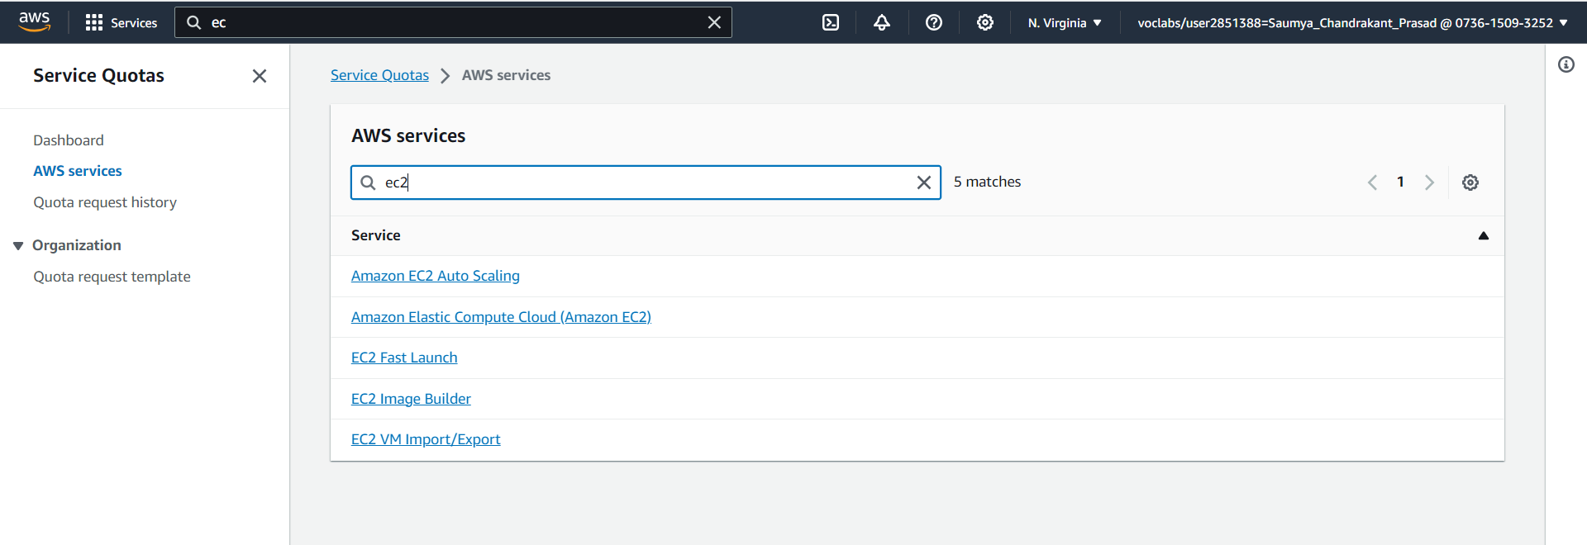

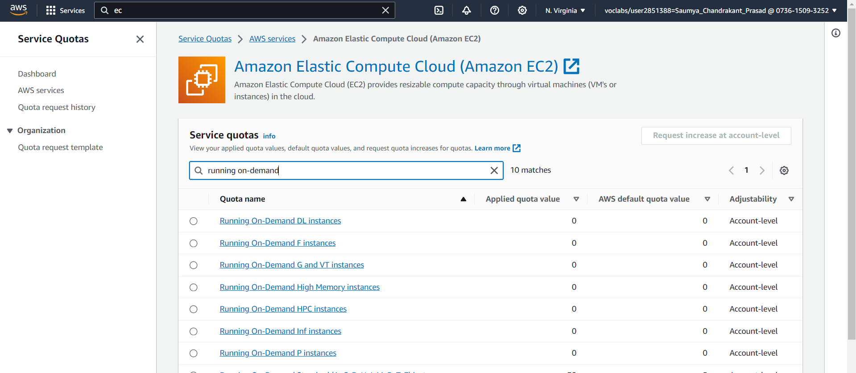

**Task 6: Test Termination Protection**

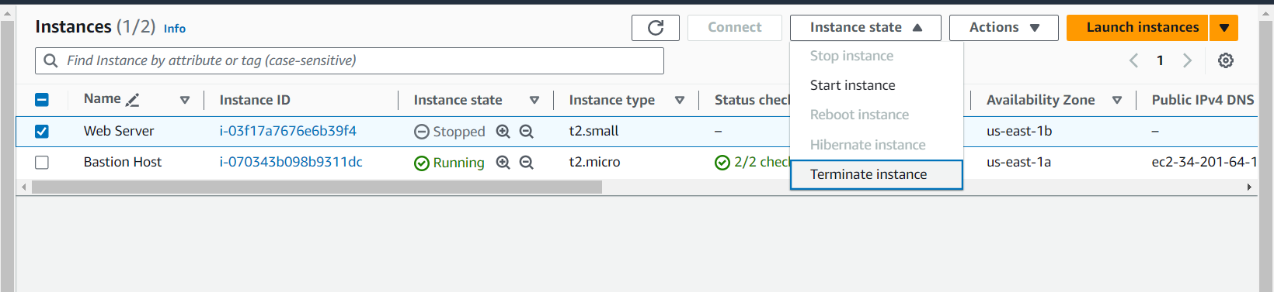

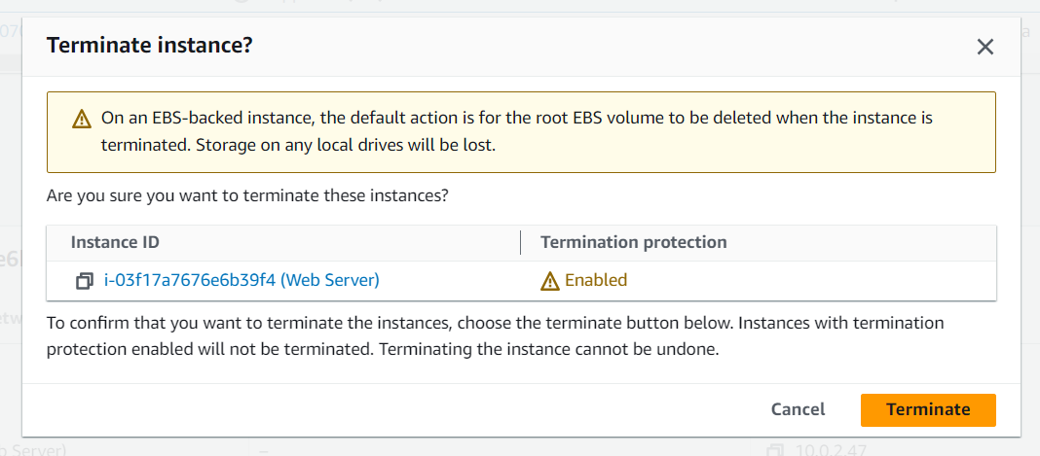

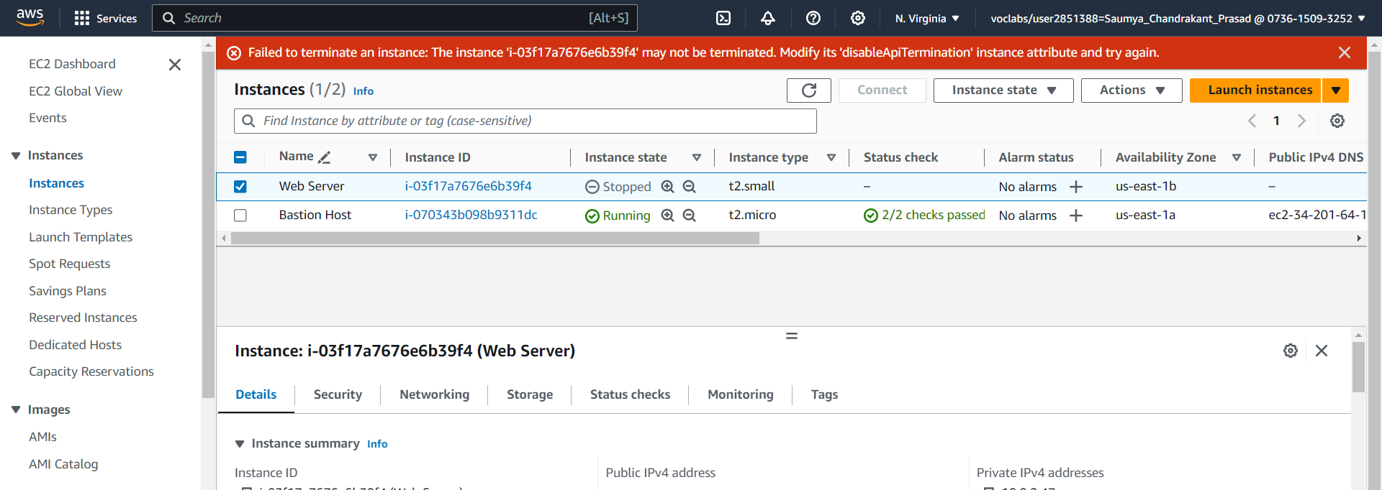

Change termination protection from **Disable** to **Enable**

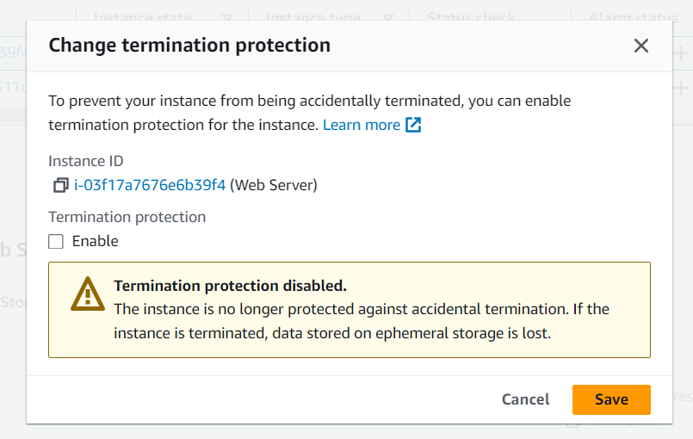

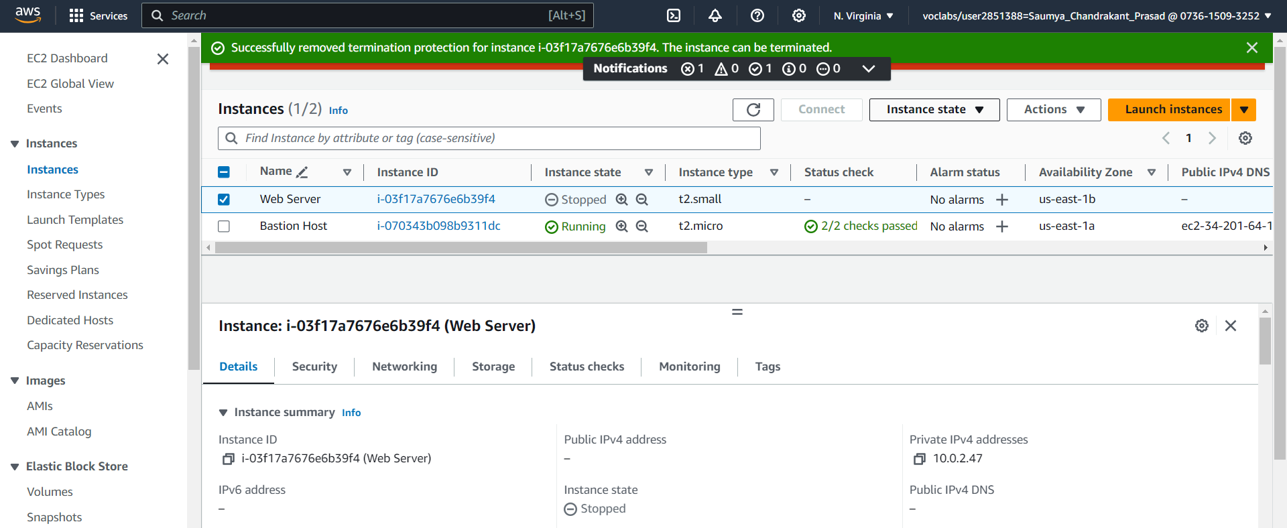

Instance terminated

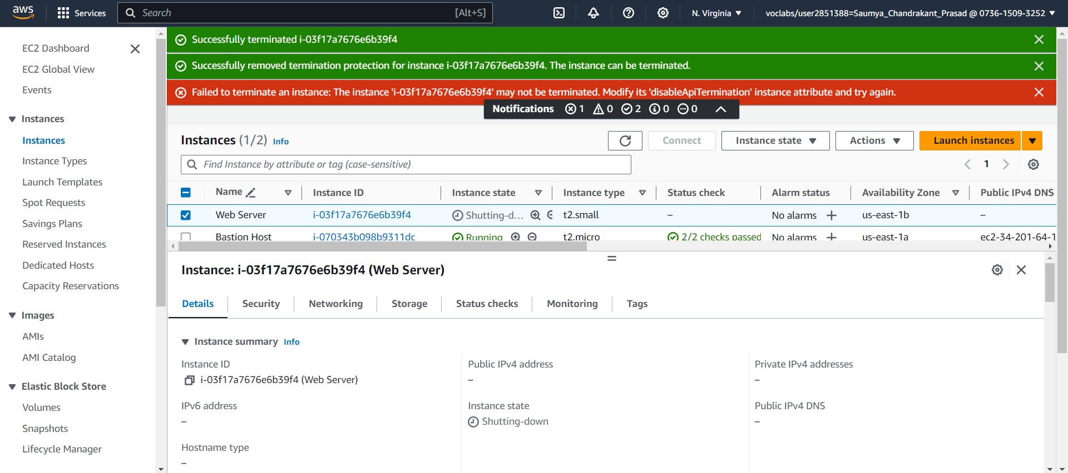

Lab ended.

Thus, this lab provides you with a basic overview of launching, resizing, managing, and monitoring an Amazon EC2 instance.